EM3630A
Portable Microhmmeter

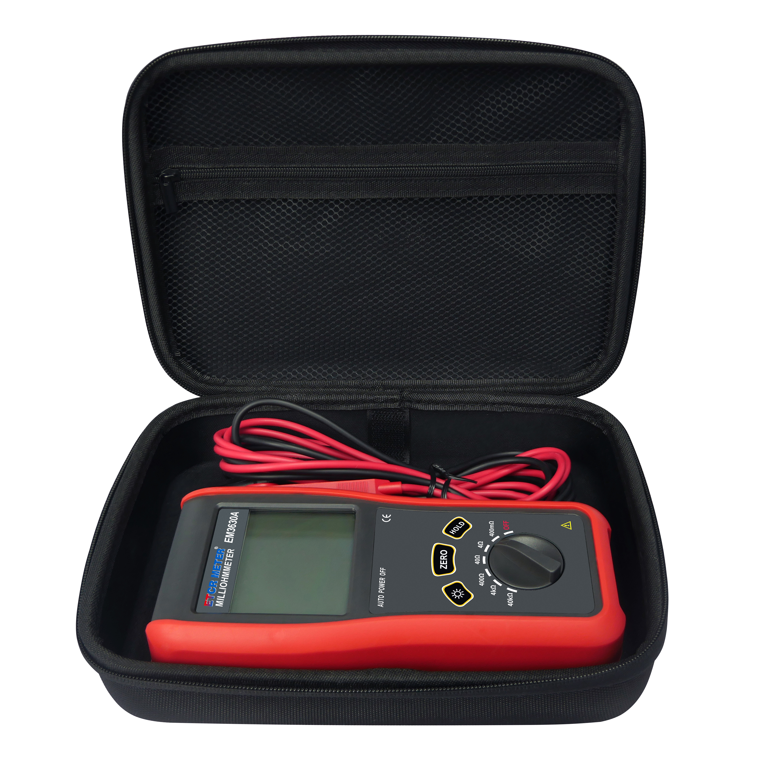
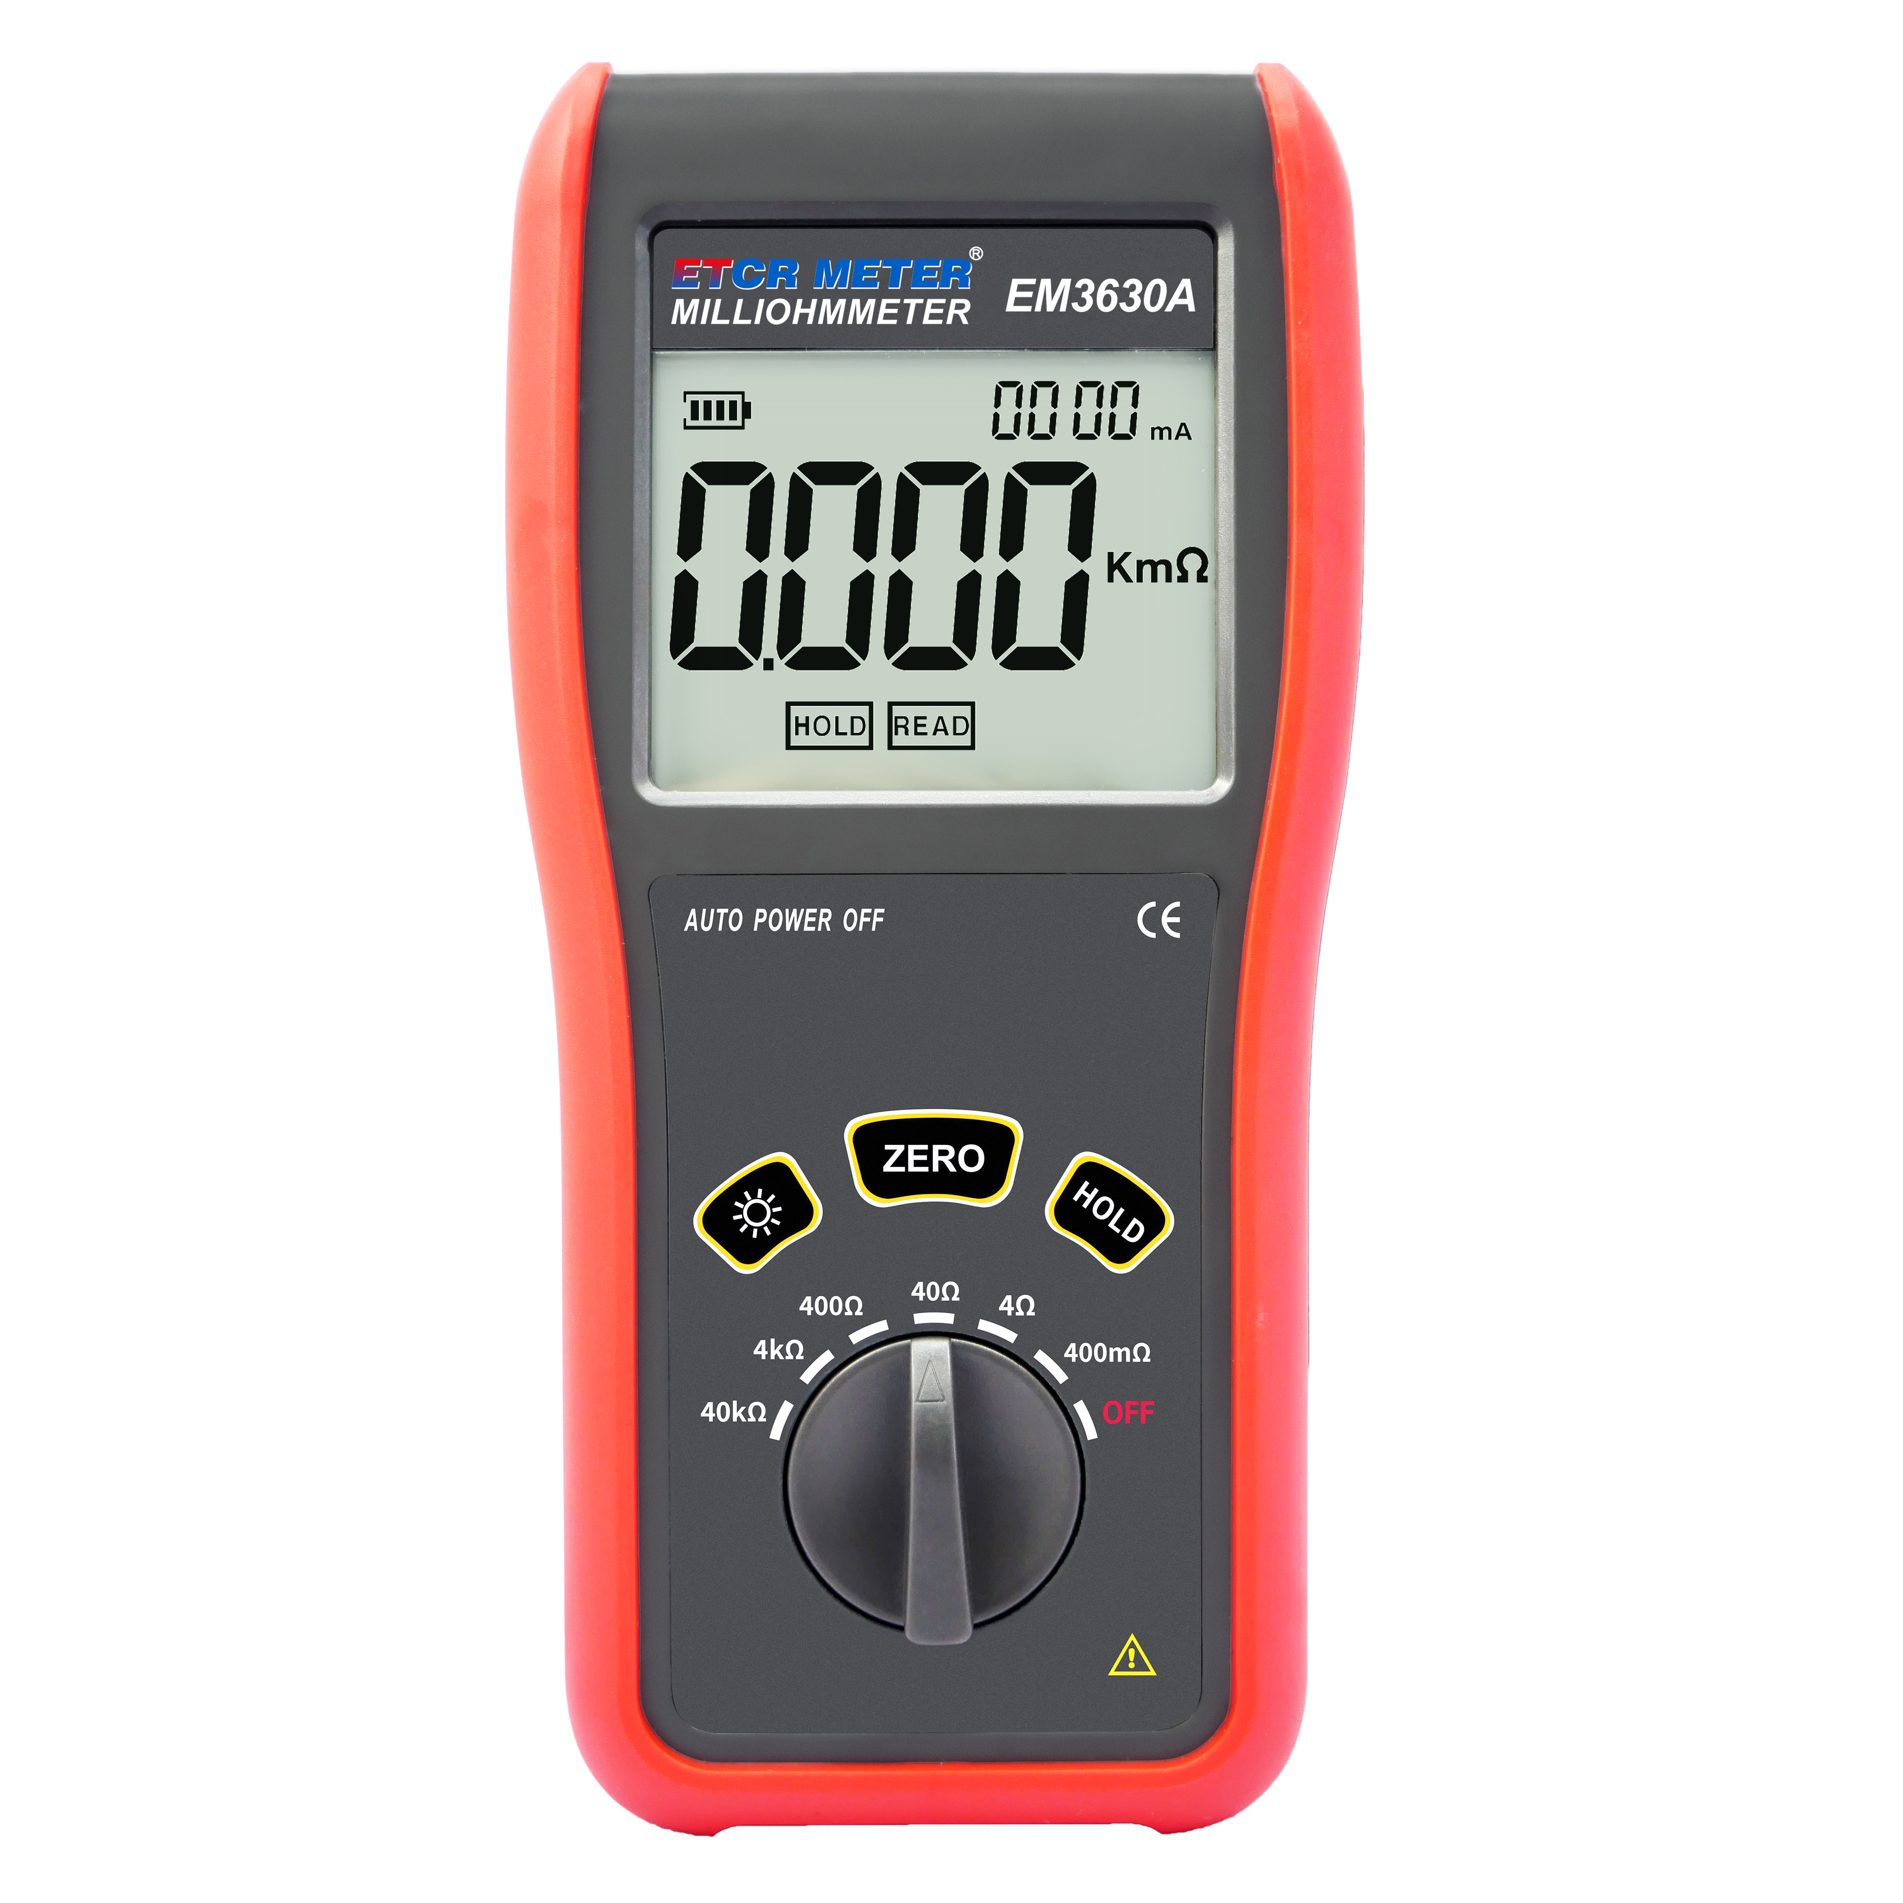

Product Function

- It is used to measure the resistance of cables, contact resistance of switches, connectors and relays, DC resistance of coils, motors and transformer windings, as well as the connection resistance of metal rivets, between metal components and of connecting conductors between ground grid electrodes.
Product Features

- It adopts the precision four-wire method, which reduces the influence of wire resistance and improves test accuracy.
- The instrument is light in weight, simple to operate and easy to carry.
- It is equipped with fast wire resistance calibration function for more accurate measurement.
- It has wide measurement range of 0.1mΩ ~ 40.00kΩ, with high accuracy and stable measurement performance.
Measurement Gear & Accuracy Specification
Gear | Accuracy | Resolution | Test Current
400mΩ | ± 0.3% ± 4dgt | 0.1mΩ | 100mA
4Ω | ± 0.3% ± 4dgt | 1mΩ | 10mA
40Ω | ± 0.3% ± 4dgt | 10mΩ | 10mA
40Ω | ± 0.3% ± 4dgt | 0.1Ω | 0.8mA
4kΩ | ± 0.3% ± 4dgt | 1Ω | 0.8mA
40kΩ | ± 0.3% ± 4dgt | 10Ω | 0.08mA

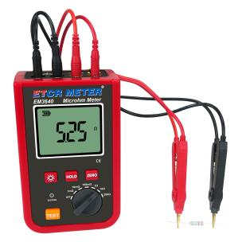
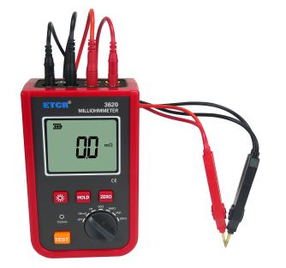
Wire Resistance Calibration
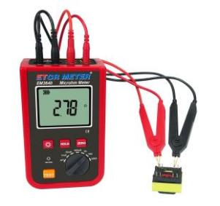
Transformer Wire Resistance Measurement
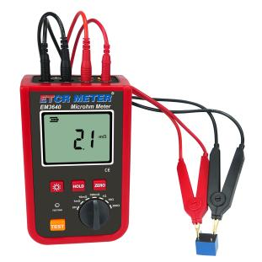
Relay Measurement
Technical Specification

Power Supply | 5 alkaline dry batteries (LR6 1.5V x 6PCS)
Display Mode | 4-digit LCD, display area: 58.5mm x 46mm
Measuring Range | 0.1mΩ ~ 40.00kΩ
Detection Method | Precision four-wire method, 2-channel A / D simultaneous detection
Data Storage | 1000 groups, data will not be lost in case of power failure or battery replacement
Test Wires | 1 set of red wires and 1 set of black wires,  cable length: 0.8m
Backlight Function | Yes, suitable for dimly lit places
Calibration Function | Yes
Low Voltage Indication | A low battery symbol is displayed to remind battery replacement
Host Dimensions | 159mm x 100mm x 66mm
Weight | Approx. 0.94kg (including accessories)
Working Temperature & Humidity | - 10℃ ~ 40℃; below 80%RH
Storage Temperature & Humidity | - 10℃ ~ 60℃; below 70%RH
Withstand Voltage | AC 3700V/rms (between enclosure and screws)
Accessories | Instrument*1PC;  Test wires*1SET;  LR6 batteries*6PCS;  Tool bag*1PC

